EXPERIMENT 4 LIBRARY BOOK RESERVATION

Step1:Create the application for ‘Library Book Reservation’

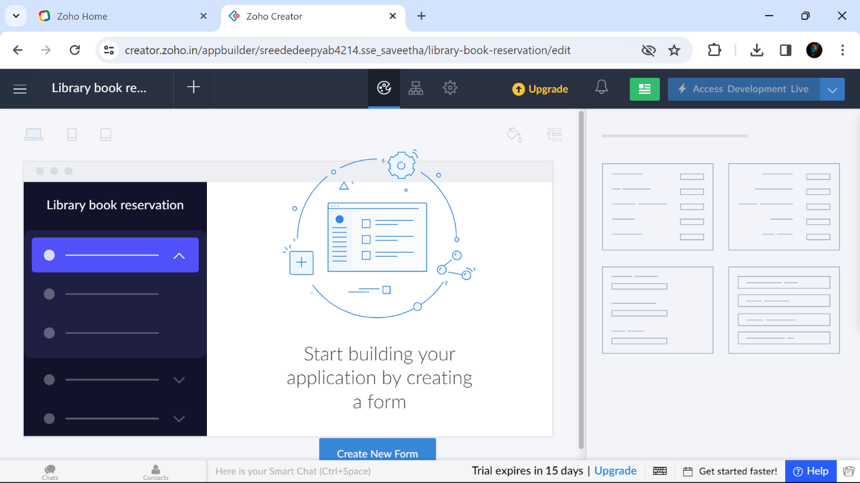

Step2: Create a form in Library Book Reservation as Personal Details

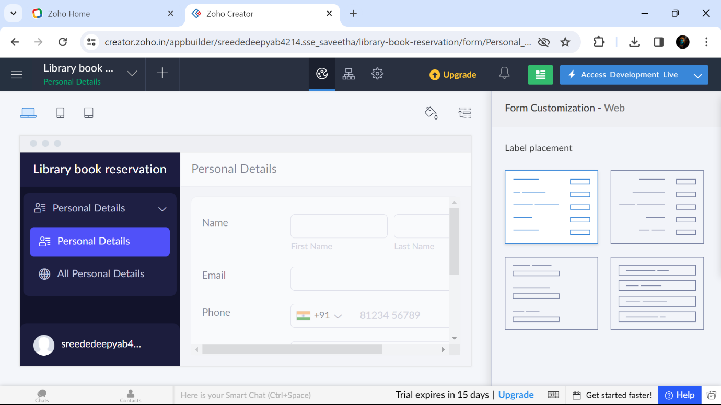

Step2: Create a form in Library Book Reservation as ‘About the Book’

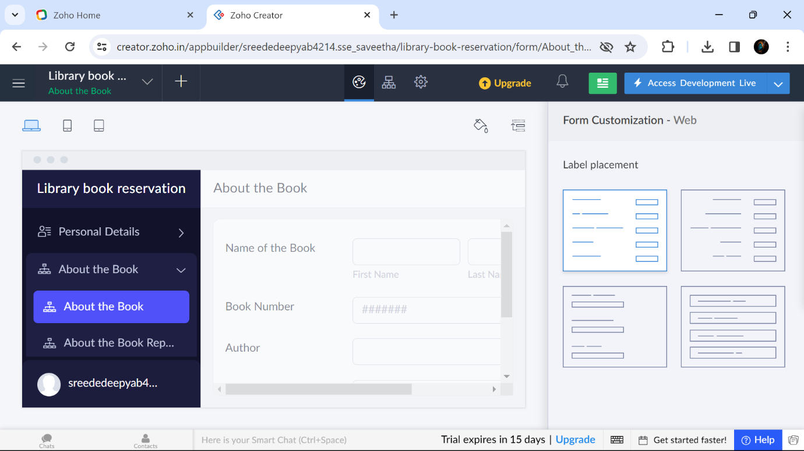

Step3: A form called Personal Details has been filled with these details

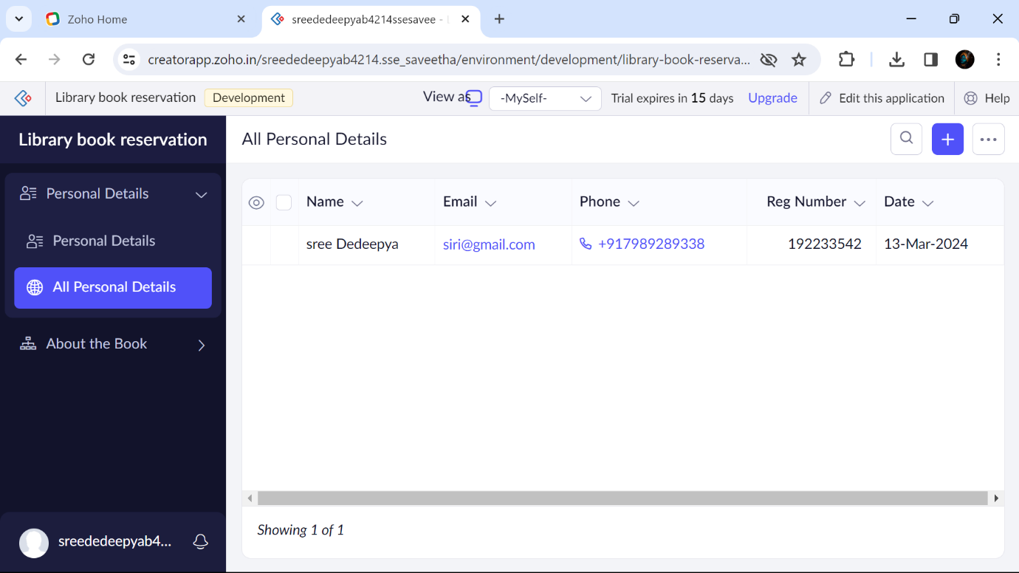

Step4: A form called About the Book has been filled with these details

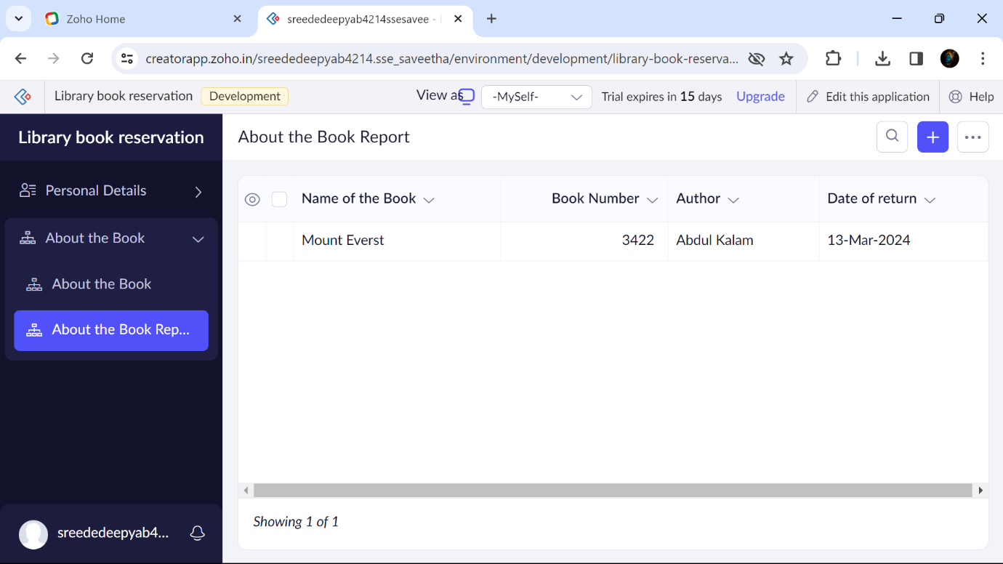

B.SREE DEDEEPYA 192224214